EXPERIMENT 7
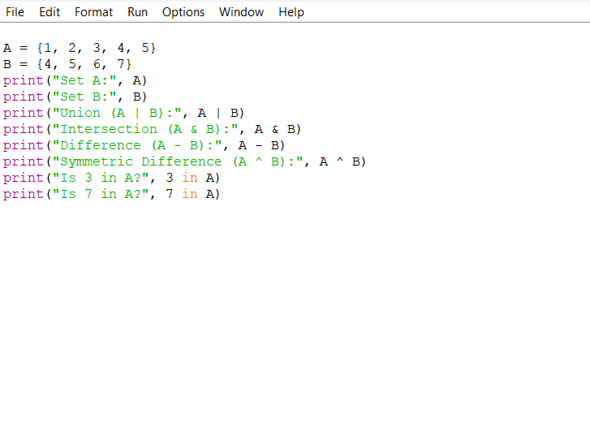
OUTPUT
